**

**Behaviour Management & Bullying Policy**

**Ratification by Full Governing Body: July 2018**

**Ethos**

At Rosh Pinah we value every child and delight in their uniqueness and creativity. We believe that every child should be given the opportunity to fulfil their potential and be their very best self.

We are a warm, friendly, welcoming school where everyone looks out for each other. Our children enjoy coming to school every day as it is a place where they have many opportunities to explore and discover their passions in an environment where they feel safe and secure.

**Rationale**

The School Behaviour Management Policy is designed to encourage the way in which all members – pupils, staff, parents and governors - can work together in a mutually supportive way. It aims to promote an environment where everyone feels safe and secure and where the health and well-being of individuals are paramount. Relationships should be based on fairness, honesty, courtesy and consideration.

**Aims**

* Enable the children to make the ‘right choices’ in terms of their actions and reactions.
* Develop a caring and positive attitude towards others, the environment and property.
* Foster an awareness of good citizenship.
* Develop links between home and school, which will provide children with a frame
* Framework of acceptable standards of social skills and behaviour.
* Ensure learning and teaching is inclusive and enjoyable.

**Philosophy**

Intelligent Discipline is built on the principles of Assertive Discipline as interpreted by Canter (USA). Our belief at Rosh Pinah Primary School is that the management of pupil behaviour should always be a positive process. Punishment contains behaviour – reward changes behaviour.

**In the classroom teachers should:**

* Be clear about Intelligent Discipline rules – and apply them consistently
* Consistently reward pupils every day for keeping to the rules i.e. behaving well
* Be assertive – but not aggressive or pleading – with pupils
* Apply the sanctions and consequences fairly and firmly. Always give pupils the chance to choose to behave
* Follow the stepped sanctions

**The Learning Environment**

Our aim is to ensure that the learning environment is conducive to professional success and that we run a ‘calm school’. Our vision for the learning environment is that it is both intentional and responsive. Our core values and philosophy ensure that we are clear about our aspirations and behaviours and provide the contact and the support for an effective learning environment.

‘Education should reflect...enduring values...These include valuing ourselves, our families and other relationships, the wider groups to which we belong, the diversity in our society and the environment in which we live.’

*The National Curriculum – Handbook for Teachers in England*

Our Behaviour Management Policy focuses on positive behaviour management and is promoted and supported in the following ways:

**School Learning Pledge (adults and pupils) believes that we all learn best when:**

* Learning is fun
* Others care if we learn
* We use our best learning style
* Learning is well planned, purposeful and relevant
* We understand and see the whole picture
* We are told regularly how well we are doing and how we can improve
* We feel safe, secure and able to take risks

**School Core Values**

* Choose a positive attitude
* Do the right thing and show compassion
* Treat others as you would wish to be treated yourself
* Show courage, take risks and learn from our mistakes
* Give to others when you can and accept help when needed
* We all share responsibility for the future
* Be there for each other
* Make someone’s day
* Respect everyone
* Work hard, have fun
* Keep going even when things seem difficult.

**7 TOP TIPS FOR THE ASSERTIVE TEACHER**

* Stay calm – stand still
* Speak – don’t shout
* Be consistent and relentless
* Be the adult – do the right thing
* Plan ahead – have a script
* Be enthusiastic – have fun!
* Be positive – reward and praise frequently

**Look at this checklist**

* Direct pupils to do the right thing
* Teach the behaviour you want (like the volume of talk)
* Never threaten – always give a choice and mean it e.g. “You are out of your seat without permission”
* You know that is against the rules. You have a choice. Either...or...you know what will follow”
* Ask fewer questions, especially starting with “Why” (They will always have an answer!)
* Directions are not requests – e.g. ‘Jack, I need you to sit down immediately!’
* Use inclusive and communal language such as ‘we’, ‘our’, ‘us’, and ‘everyone’
* Keep track of rewards and consequences – small and stepped

**Summary of our approach to discipline**

* Be assertive with pupils, not hostile, not pleading
* Recognize good behaviour every lesson
* Be consistent
* Deal with Level 1 disruption in your class – give verbal warnings, set out consequences
* Remind and teach the rules
* If a child repeats poor behaviour give 2nd, 3rd 4th and 5th consequences
* If a sixth step is reached or there is extreme poor behaviour the pupil will be removed from class and placed with a member of SLT.

**School Rules**

1. We follow adults’ instructions
2. We listen in silence
3. We use kind words, hands and feet
4. We look after each other and our school

**School Corridor Rules**

* We follow adults’ instructions
* We walk calmly and keep to the left
* We talk quietly
* We go straight to your lesson
* We put all litter in the bins

**Rewards for Positive Behaviour**

We have 5 steps to reward children for good behaviour, effort and learning each day.

Step 1. Verbal praise

Step 2. Issuing up to 3 Class Dojos

Step 3. Issuing up to 6 Class Dojos

Step 4. Issuing up to 9 Class Dojos + a note home to parents

Step 5. Issuing up to 12 Class Dojos + a postcard sent home in post

The Dojo points earn badges handed out in assembly and their names are placed on the ‘*Derech Eretz’* reward board:

* 120 points = bronze badge
* 240 points = silver badge
* 360 points = gold badge
* 480 points = diamond badge
* 600 points = star pupil badge

**House points**

All children belong to a house group in which they remain. Each week the children add their dojo points to a collective score for their house and the winner for the week is announced in assembly and displayed on the notice board. At the end of each term the winning house gains additional playtime.

**Sanctions for Negative Behaviour**

If children are not following the school rules the following stepped sanctions will be followed each day:

Step 1. Verbal warning 1

Step 2. Verbal warning 2

Step 3. 5 Minute Reflection time in class + 1 minute detention by class teacher before play

Step 4. Withdrawn to another class + 2 minute detention by class teacher before play + parents informed

Step 5. 10 minute detention by Phase Leader + parents informed

Step 6. *SLT Detention (letter sent home to parents)*

Step 7. Continued disruption Child to be placed on report for between one and two weeks and monitored by Phase Leader

Step 8. Continued disruption Child to be placed on report for between one and two weeks and monitored by SLT. The Headteacher and school reserves the right to withdraw privileges from pupils who misbehave. This may include withdrawal from representing the school at an organised event, participation on a school trip or anything else deemed appropriate.

Step 9. Internal exclusion monitored by SLT *(letter sent home to parents)*

The following table shows which steps must be recorded on class dojo or on behaviour incident form:

|  |  |  |  |  |  |  |  |
| --- | --- | --- | --- | --- | --- | --- | --- |
| Level | STEP | | Detention | Record on board & Class dojo | Record on SIMS | Incident form | Phone  parents |
| Level 1 | 1 | Verbal warning 1 |  | Yes |  |  |  |
| 2 | Verbal warning 2 |  | Yes |  |  |  |
| 3 | Reflection time (move in class) | 1 minute | Yes |  |  |  |
| Level 2 | 4 | Withdrawn to another class | 2 minutes | Yes |  | Yes | Yes |
| 5 | 10 minute detention  Phase Leader | 10 minutes | Yes |  | Yes | Yes |
| Level 3 | 6 | SLT detention | 20-30 minutes | Yes | Yes | Yes | Letter home |
| 7 | Report Card shown to Phase Leader |  | Yes | Yes | Yes | Report Card signed daily by parent and Phase Leader |
| Level 4 | 8 | Report Card shown to SLT |  | Yes | Yes | Yes | Report Card signed daily by parent and SLT |
| 9 | Internal Exclusion with SLT | Up to 1 whole day with break at separate time to rest of year.  Continued misbehaviour to be given extended periods of internal exclusion. | Yes | Yes | Yes | Letter home |

**Levels of Behaviour/Consequence Map**

*The Consequences map (appendix 4)* sets out the 4 levels of behaviour incidents:

Level 1 - Low level disruption

Level 2 - Disobedience/Obstructive Behaviour

Level 3 - Continued disruption/Destructive behaviour/Aggressive behaviour

Level 4 - Repetition of level 2&3

Levels 1 and 2 should be dealt with by the class teacher. Phase Leaders and Senior Leadership should be involved at Level 3 and 4.

**Serious Behaviour Incidents**

Destructive or aggressive behaviour (Level 3 or 4) is considered a serious incident as opposed to a continuation of Level 1/2 behaviour and should be recorded on the *Step 4/5 Behaviour Incident Form.* A copy should be given to SLT and given to the office to record on SIMS and file for future reference.

**Playtime and Lunchtime**

At playtime and lunchtimes we aim to provide a range of activities to engage children in positive play with their peers. This includes the play equipment or each key stage and structured games which are led in KS2 by Play Leaders with the focus on co-operative play, good communication and teamwork. We also have a system of prefects to support younger pupils and some additional lunchtime clubs such as Choir, Table Tennis, and Book Club.

Our playground rules are the same as our school rules

1. We follow adults’ instructions
2. We listen in silence
3. We use kind words, hands and feet
4. We look after each other and our school

**Rewards for Positive Behaviour at Play and Lunchtimes**

Step 1. Verbal praise

Step 2. 1 sticker

Step 3. 2 stickers

Step 4. Note home to parents

Step 5. Postcard home through post to parents

Additional awards

* Class dojos awarded to smartest and quietest line. Class with most points in a week to be awarded a certificate.
* Responsible Citizen Playground Award (certificate) awarded at assembly for pupil who include others and is a model citizen at playtime and lunchtime

**Sanctions for Negative Behaviour**

If children are not following the playground rules the following stepped sanctions will be applied each day. Staff may apply a higher sanction without going through each step for significant misbehaviour:

Step 1. Verbal warning 1

Step 2. Move to different area of playground

Step 3. Reflection time + 2 minute time out (at bench, staff to monitor)

Step 4. 5 minutes time out (at bench, staff to monitor)

Step 5. Pupil removed from playground, to sit outside office of member of SLT.

Step 6 Loss of next break

*Step 7. SLT Detention (letter sent home to parents for continued breach of the playground rules or serious behaviour incident)*

**Playground Sanction Guidelines**

|  |  |  |
| --- | --- | --- |
| Level 1 (Handled by playground staff) | Level 2 | Level 3 |
| * Name calling * Talking back (defiance) * Minor incident e.g. pushing * Areas of playground not being used appropriately * Dropping litter * Minor arguments * Disregarding instructions of playground staff * Disrupting games | * Consistent level 1 behaviour * Picking on other children * Swearing * Arguing/being insolent to staff * Refusal to comply with instructions | * Fighting * Physically abusive to staff/pupils * Endangering others &/ or themselves * Damaging property * Entering the incorrect playground |
| Sanction   1. Reminder of playground rules 2. Verbal warning 3. Move to different area of playground 4. 2 minutes time out (at bench, staff to monitor) | Sanction   1. 5 minutes time out (at bench, staff to monitor) 2. Class teacher to be informed at the end of break. | Sanction   1. Pupil removed from playground. 2. Loss of next break 3. Incident logged 4. Parents notified 5. Behaviour contract set up if happening regularly. 6. SLT detention |

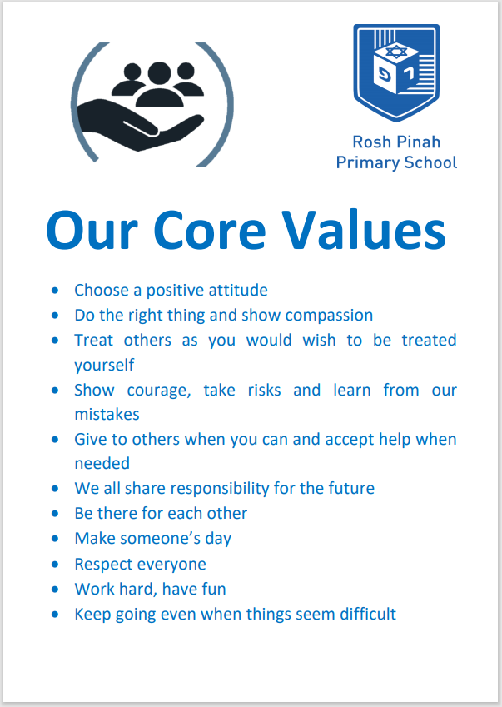

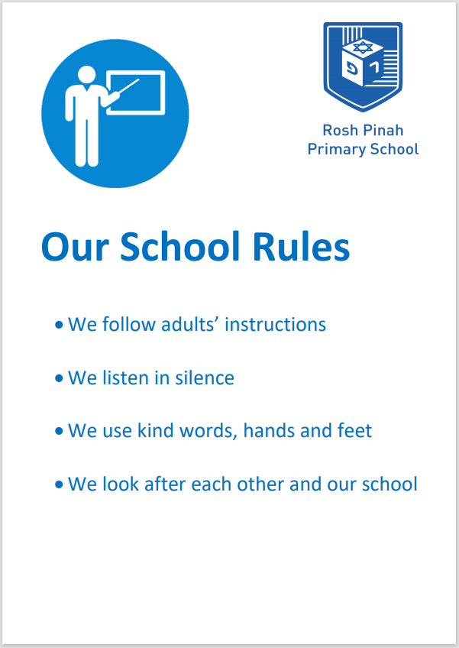

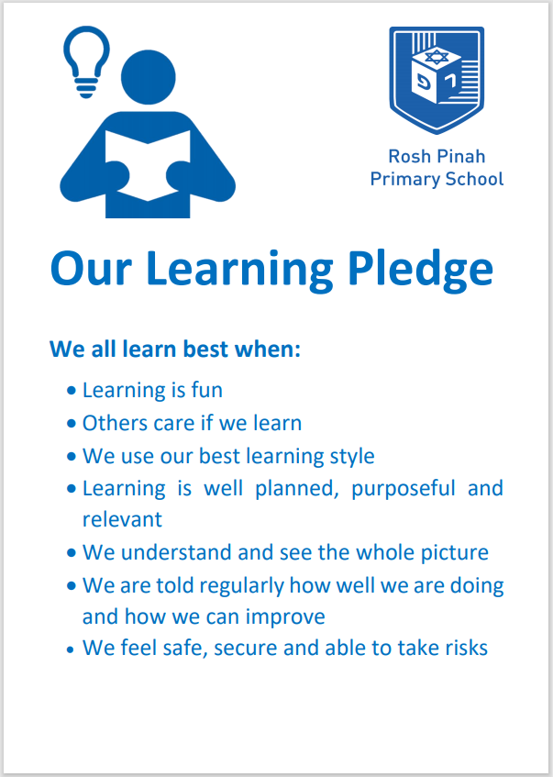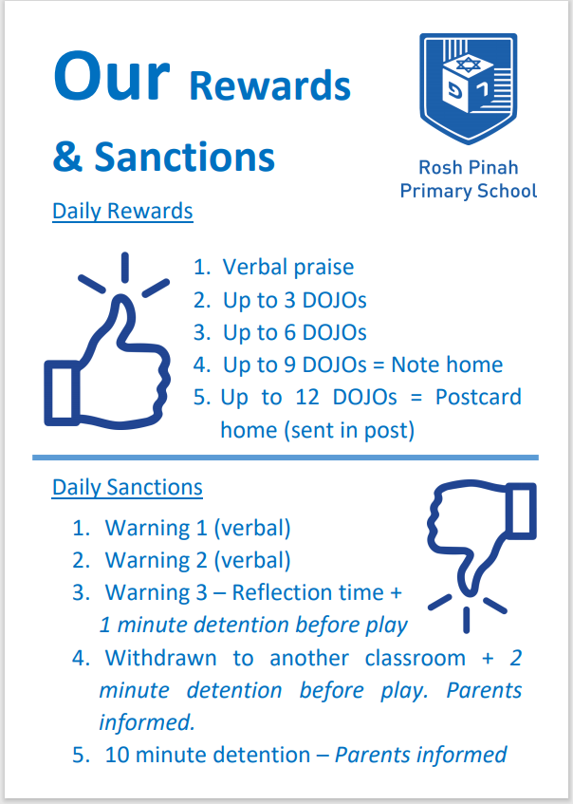

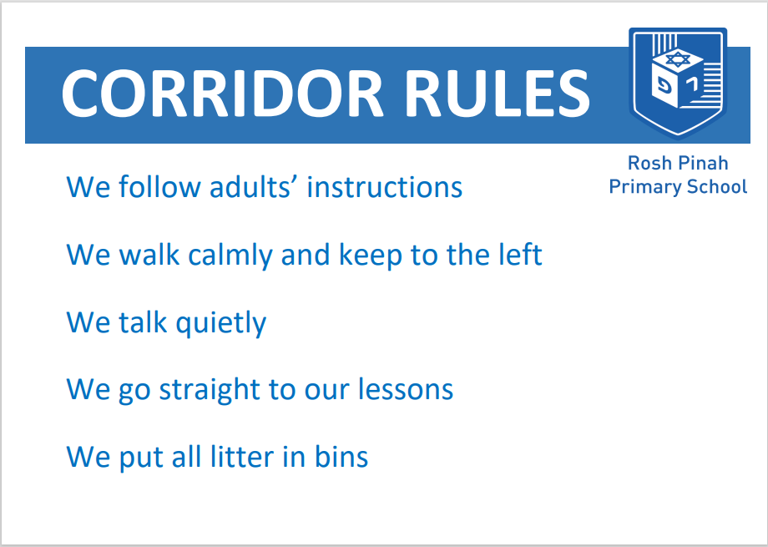

**Wet Break**

To promote positive behaviours during wet break times the following actions should be taken:

* Children should be supervised at all times by staff;
* Break times should be kept within normal times so as not to cause disruption;
* Children should be adequately occupied e.g. having their snack or playing games, or reading etc.;
* A ‘wet play’ activity box with designated games, activities and equipment, supervised by sensible monitors, should be in use.

**Staff Responsibilities** *(Appendix 1 – Code of Conduct)*

* To role model good behaviour and positive relationships.
* To create a positive climate with realistic expectations.
* To emphasise the importance of values and being valued.
* To provide an effective learning and teaching environment.
* To encourage positive relationships based on kindness, empathy and respect.
* To ensure fair treatment of all regardless of ability, age, sex, race or preconceptions.
* To show appreciation of the efforts and contributions of everybody.
* To ensure that children actually receive rewards every time they have earned them and receive a sanction every time they behave badly.
* To carefully following each stage of the behaviour policy rather than over reacting to poor behaviour or simply remembering to stay calm.
* All are responsible for the modelling of good behaviour, positive relationships and dealing with incidents around the school (teachers, support staff and lunchtime supervisors).

**Children’s Responsibilities**

Children are expected to follow the School Rules and individual classroom codes of conduct, showing respect for the rights and needs of all adults and all children in our school community.

**Parents’ Responsibilities** *(Appendix 1 – Code of Conduct)*

Parents have a vital role to play in their children’s education, supporting their child’s learning and co-operating with the school. We are very conscious of the importance of good communication between home and school. Thus the school aims to work collaboratively with parents so children receive consistent messages about how to behave at home and school. It is important for all adults on school site including parents to model positive behaviour at all times and in particular in their interactions with each other.

We display the school rules, rewards and consequence system on the school website. We have a Home School Agreement which is signed by pupils, parents and teachers. We expect parents to read these and support them. If parents have any concerns about the way their child has been treated they should initially contact the class teacher. The Deputy Head may then be involved then the Headteacher.

We expect parents to behave in a reasonable and civilised manner towards all school staff as professionals and that issues will be dealt with in an atmosphere of trust and mutual respect. Incidents of verbal or physical aggression to staff by parents/carers of children in the school will be reported immediately to the Headteacher who will take appropriate action in line with Local Authority Policy.

**Special Educational Needs**

We recognise for a small number of children whose behaviour is beyond the whole school rewards and consequence system a more personalised approach may be necessary in order to support them in developing the ability to regulate their own behaviour. They may have an individual behaviour plan agreed between the pupil, staff and parents. The support of outside agencies will also be sought where appropriate.

**Serious Misdemeanours**

Serious misdemeanours may be dealt with in the following ways:

* Involvement with a member of the Senior Leadership Team
* A major misdemeanour may result in an immediate exclusion at the discretion of the Head teacher.
* Barnet’s exclusion procedures will be followed in the case of a child’s exclusion (temporary or permanent) from the school (carried out by Head Teacher or the Deputy Head in the Head teacher’s absence).
* All exclusions will be put in the child’s records which follow the child to the next school

N.B Pupils with behaviour difficulties will be given support and guidance accordingly.

**Fixed Term and Permanent Exclusions**

We do not expect that exclusion will be required however the school is required to state its policy should an action ever be necessary. Extreme behaviour or persistent destructive or challenging behaviour may lead to a pupil exclusion. Only the Headteacher or (Acting Headteacher) has the power to exclude a child from school. The Headteacher may exclude a pupil for one or more fixed periods, for up to 45 days in any one school year. The Headteacher may also exclude a pupil permanently. It is also possible for the Headteacher to convert a fixed term exclusion into a permanent exclusion if circumstances warrant this.

If the Headteacher excludes a child he/she informs the parents as soon as possible giving reasons for the exclusion. At the same time the Headteacher makes it clear to the parents that they can appeal against the decision to the Governing Body and how to do so through the letter of exclusion.

The Headteacher informs the Local Authority and the Governing Body about any permanent exclusion or fixed term exclusion. The Governing Body itself cannot either exclude a child or extend the exclusion period made by the Headteacher. However the Governing Body has a Hearings committee whose role is set out in strict guidelines whenever a child is excluded from school.

**Pupil Voice**

Rosh Pinah Primary School has active school councils in KS1 and KS2, which meet once a fortnight. They are made up of elected representatives from each Key Stage.

Each meeting has an agenda, formed partly from issues raised by children in our school about the school and school community, issues raised by the school council at meetings and issues raised by the Headteacher, Senior Leadership Team.

The members are encouraged and trained to take an increasingly active part, particularly the older children, e.g. taking minutes – supported by the School Council Lead in KS1 and KS2.

**Attendance**

At Rosh Pinah Primary School we believe that good school attendance gives children the opportunity of success and helps develop skills for life. We believe it is vital that all children attend school every day unless there is an unavoidable cause like illness. Every child should aim to end the year with attendance above 95%.

We have 2 Attendance Awards which will be given out every Monday to the class in Reception or KS1 and KS2 who have achieved 100% attendance for the previous week. The KS2 class will receive a trophy to display in their classroom for the week and the Reception or KS1 Class will look after our Attendance Bear called ‘Dov Nochechon’ (Present Bear!). We also give termly attendance certificates for those with 100% attendance.

**Bullying**

Bullying of any kind is not acceptable at our school.

If bullying does occur, all pupils should be able to ***tell*** and know that incidents will be dealt with promptly and effectively. Anyone who knows that bullying is happening is expected to report it.

## What is bullying?

Bullying is the ***persistent*** use of verbal or physical aggression with the ***intention*** of hurting another person. It results in pain and distress to the victim.

Bullying can be:

* Emotional – being unfriendly, tormenting, excluding
* Physical – pushing, kicking, hitting etc.
* Racist – taunts, graffiti, gestures
* Sexual – unwanted physical contact or abusive comments
* Verbal – name-calling, sarcasm, teasing, spreading rumours and persistent taunting
* Cyber – misuse of internet, social networking, SMS/MMS, e-mail, mobile phones, etc. (NB: the school is not responsible if bullying occurs away from the school including journeys to and from school).

## Procedures

* Report bullying incidents without delay to a member of staff, preferably the class teacher in the first instance. If the teacher is unable to deal with it in the first instance, a member of SLT should be involved.
* The bullying behaviour or threats of bullying must be investigated immediately.
* The incidents should be recorded in writing and a member of the SLT should be informed and involved.
* The parents of the pupils involved in bullying will be informed and a letter (see below) sent to arrange a meeting to discuss the problem.
* The parents of the victim to be informed of action taken by the school.
* The victim and the bully should be counselled appropriately.
* Records of all incidents and outcomes to be kept on file and copies given to senior members of staff.
* Incidents of bullying will be monitored and followed up as appropriate.

## Strategies for the prevention and reduction of Bullying

* Whole school to participate in Anti- Bullying Week.
* Ensure that the school community understands the meaning of ‘bullying’.
* Ensure that all pupils know what to do if they, or a friend, are being bullied.
* Raise awareness of why some children may bully through our PSHE Curriculum programmes, drama, role-plays, assemblies, circle times, school council etc.
* Ensure that all staff on playground duty are visible.
* Ensure that pupils know that staff members will always listen to them.
* Playground buddies where appropriate.

***Note: To allow or condone bullying may lead to the application of child protection procedures. This includes all forms of bullying e.g. cyber, racist, homophobic and gender related bullying. The school keeps a record of known bullying incidents.***

**Cyber Bullying**

Definition- "Cyber bullying" is the use of Information Communication Technology (ICT), particularly mobile phones and the internet, to deliberately upset someone” DCSF 2007

Bullying is bullying wherever and however it take place. Cyber bullying is a method of bullying that uses ICT to upset, threaten or humiliate someone and has the following key characteristics:

* Cyber bullying can take place at any time, in any location; technology allows the user to bully anonymously
* Cyber bullying can occur on a vast and rapid scale. Electronic content is very hard to control; it can never be guaranteed to be removed totally from circulation. Bullies can take actions to attempt to be anonymous and can feel ‘distanced’ from the incident. ‘Bystanders’ can easily become perpetrators
* The ‘profile’ of a cyber-bully or a target varies – age/size is not an issue
* Cyber bullying incidents can be used as evidence
* Cyber bullying can occur unintentionally often due to a lack of awareness/empathy – ‘It was only a joke’
* Cyber bullying leaves no physical scars so it is, perhaps less evident to a parent or teacher, but it is highly intrusive and the hurt it causes may be very severe.

At Rosh Pinah Primary School, we take this bullying as seriously as all other types of bullying and, therefore, will deal with each situation individually. An episode may result in a simple verbal warning. It might result in a parental discussion. Clearly, more serious cases will result in further sanctions.

**Anti-Racism**

Like bullying, racism can exist in any school. In Rosh Pinah where its pupils are mostly all made up of one ethnicity it is extremely rare. However, we still have principles and roles in place to ensure that racism can be quickly stopped.

* All pupils should know that racism is wrong.
* Pupils should tell any adult (school staff or parent/carer) if they know of any racism in our school.
* All staff take racism seriously; they aim to ensure racism is seen as unacceptable. Teachers and teaching assistants should communicate to all children, other staff and to parents the message that racism is wrong and unacceptable at Rosh Pinah Primary and in society. Issues surrounding racism and its unacceptable nature are made very clear to all.
* The Headteacher monitors the effectiveness of staff in promoting community cohesion and positive relationships, and in providing support for victims of racism.
* The Headteacher has overall responsibility for dealing with racist incidents and recording the action taken.
* All racist incidents will be dealt with no matter how trivial they may seem to be. If staff are aware of racism, they should refer it to the Headteacher or Deputy Head directly.

**Incident book**

All incidents are recorded on the relevant behaviour form. A copy is to be placed in the pupil’s file and copies given to the Assistant Headteacher.

**PSHE (Personal, Social, Health and Economic) Education**

Personal, Social, Health and Economic (PSHE) education is an important and necessary part of all pupils’ education. We teach PSHE, drawing on good practice, an expectation which is outlined in the introduction to the new National Curriculum 2014.

PSHE is a non-statutory subject. To allow teachers the flexibility to deliver high-quality PSHE we consider it unnecessary to provide new standardised frameworks or programmes of study. PSHE can encompass many areas of study. Teachers are best placed to understand the needs of their pupils and do not need additional central prescription.

Although PSHE is a non-statutory subject we tailor a PSHE programme to reflect the needs of our pupils and to equip them with a sound understanding of risk and the knowledge and skills necessary to make safe and informed decisions.

We seek to use PSHE education to build, where appropriate, on the statutory content already outlined in the national curriculum, the basic school curriculum and in statutory guidance on: drug education, sex and relationship education (SRE) and the importance of physical activity and diet for a healthy lifestyle.

**Use of Physical Restraint**

We always aim to create a calm and safe environment which minimises the risk of incidents arising that might require the use of physical intervention.

All staff should help students take responsibility for their own behaviour through

* positive role modelling
* teaching an interesting and challenging curriculum
* setting and enforcing appropriate boundaries and expectations
* providing supportive feedback.

We strongly believe in de-escalating any incidents as they arise to prevent them from reaching a crisis point. Staff will be skilled in promoting and rewarding positive behaviour and will utilise various appropriate techniques in the management of a class environment. Staff will only physically intervene when the risks involved in doing so are outweighed by the risks involved by not using reasonable physical intervention.

Staff should avoid using physical intervention. For behaviours involving a high level of risk staff should call for another member of staff to be present to support and observe or call for assistance from a member of the Senior Leadership Team

In the event that a child needs to be physically restrained staff should only use the minimum amount of restraint in achieving the required outcome within the context of existing good practice. Staff should, where possible, avoid any type of intervention that is likely to injure a pupil, unless in the most extreme of circumstance where there was no viable alternative.

**Searching, Screening and Confiscation of Electronic Devices in School**

Staff may lawfully search electronic devices, without consent or parental permission, if there is a suspicion that the pupil has a device prohibited by school rules or the staff member has good reason to suspect the device may be used to:

* cause harm
* disrupt teaching
* break school rules
* commit an offence
* cause personal injury
* damage property.

Any data, files or images that are believed to be illegal must be passed to the police as soon as practicable, including pornographic images of children, without deleting them.

Any data, files or images that are not believed to be unlawful, may be deleted or kept as evidence of a breach of the School's Behaviour Policy.

**Inclusion**

This policy like all our policies recognises the right of all children to be included in all aspects of the curriculum and to have their progress assessed.

Since all classes contain pupils whose abilities cover a wide range, teachers must make every effort to promote inclusion of all pupils by using appropriate class management and assessment strategies and collaborative teamwork with other members of staff. All lesson planning should allow for differentiation of tasks so that they are suitable for all levels of ability in the class.

At Rosh Pinah, our values embrace inclusion. We aim to ensure that we promote the inclusion of all members of the school including children, parents, staff, governors and the local community in accordance with Orthodox Jewish practice. Our framework is based on suitable learning challenges, responding to each pupil’s diverse learning needs and overcoming potential barriers to learning so that all stakeholders in all areas of school life can participate as fully as possible.

**Recording, Monitoring and Evaluating Behaviour**

The Senior Leadership Team will monitor behaviour and evaluate the impact of this policy through records, informal observations, comments from formal observations and discussions with pupils, staff and parents.

**OTHER RELATED POLICIES**

**This policy also links to Rosh Pinah Policies on:**

* How to Raise a Concern
* Teaching and Learning
* E Safety Policy
* Code of Conduct for Staff, Volunteers and Governors
* Inclusion Policy
* Foundation Stage Behaviour Management Policy
* Mobile Phone Policy
* Prevent Policy

This policy will be reviewed annually with opportunities for consultation with staff, pupils and parents.

**First produced Feb 2007**

**Revised June 2012**

**Rewritten July 2014**

**Ratified by Governors October 2014**

**Updated October 2015**

**Updated February 2016**

**Updated June 2017**

**Updated July 2017**

**Updated July 2018**

**Ratified by Governors July 2018**

**Updated November 2019**

**Updated October 2020**

***Appendix 1***

 **Code of Conduct for Staff, Governors,**

**Volunteers and Parents**

Ratified by the Governing Body September 2018

All staff, governors and volunteers at Rosh Pinah Primary School have a responsibility to keep children safe and are accountable for the way in which they exercise authority and maintain positive professional relationships with children and colleagues. Adults who work with children are in a position of trust and it is therefore essential to maintain appropriate professional boundaries and avoid any behaviour which could be misconstrued by others. This summary aims to highlight some of the key elements in staff behaviour which helps to promote a safe professional culture.

Parents have a responsibility to maintain a good working relationship with the school to equip children with the necessary skills for adulthood. The Code of Conduct for parents/carers and visitors is to provide a reminder about the expected conduct in our school so we can continue to flourish, progress and achieve in an atmosphere of mutual understanding.

**Staff and Volunteers should:**

* Work in an open and transparent way, avoiding any actions that would lead a reasonable person to question their motivation and/or intentions
* Dress in accordance with the School’s Dress Code
* Ensure everyone within the school is treated with respect and dignity and avoid the use of sarcasm, demeaning or insensitive comments
* Ensure that areas of the curriculum that may involve sensitive information are taught in accordance with school policies
* Allow children to change clothes with levels of respect and privacy appropriate to their age, gender, culture and circumstances
* Arrange to meet with pupils in closed rooms with a glass panel or window. Where this is not possible the door need to be left ajar
* Avoid working in one-to-one situations or conferring special attention on one child unless this is part of an agreed school plan or policy
* Only use physical contact that is in response to a child’s needs, in a manner that is appropriate to their professional role
* Avoid situations where they may be alone with a child without the sight of other children or staff members
* Understand their position of power and influence over children and not misuse it in any way. This includes but is not limited to:
* accepting regular gifts from children over and beyond small tokens of appreciation as a thank you or on special occasions
* giving personal gifts to children outside of an agreed framework
* Maintain a professional relationship with pupils, ensuring that children do not become too familiar with staff and vice versa
* Not establish or seek to establish inappropriate contact with pupils outside of school unless they are relatives or have a pre-existing relationships within the community. This includes:
* communication with pupils in inappropriate ways, including personal e-mails and mobile telephones
* contact through social networking sites
* passing your home address, phone number, e-mail address or other personal details to pupils
* the transportation of pupils in your own vehicle without prior management approval
* Read, understand and adhere to the schools Child Protection and Safeguarding Children Policy to allow them to make sensible judgements about the wellbeing/safety of any child and to understand the correct line of action to take if there are concerns.
* Model the characteristics they are trying to inspire in pupils, including enthusiasm for learning, a spirit of enquiry, honesty, tolerance, social responsibility, patience, and a genuine concern for other people
* Work in line with the school’s E-Safety Policy
* Work in line with the school’s policy for the use of force to control or restrain pupils
* Never use a physical punishment of any kind
* Maintain a safe and hygienic building and grounds
* Maintain confidentiality. Where staff/volunteers have access to confidential information about pupils/students or their parents or carers, staff must not reveal such information except to those colleagues who have a professional role in relation to the pupil/student
* Ensure that their behaviour, either in or out of the workplace, should not compromise her/his position within the work setting or bring the school into disrepute
* Inform the Headteacher if a pupil may be infatuated with you or taking an above normal interest in you.

**In addition volunteers should:**

* Work within the school routine. The school has certain procedures and policies that are in place to keep us safe as well as working
* Not verbally or physically discipline children. Refer any problems to the teacher.

**Governors should:**

* Have responsibility for determining, monitoring and keeping under review the broad policies, plans and procedures within which the school operates
* Recognise that the Headteacher is responsible for the implementation of policy, day-to-day management of the school and the implementation of the curriculum
* Have equal status, with the overriding concern being the welfare of the school as a whole
* Have no legal authority to act individually, except when the governing body has delegated authority to do so or where the Chair of Governors has individual authority granted by statute and regulations.
* Act fairly and without prejudice, with responsibility for staff
* Consider carefully how our decisions may affect other schools
* Strive to work as a team and seek to develop effective working relationships with the Headteacher, staff and parents/carers, the LA and other relevant agencies and the community
* Observe complete confidentiality, especially regarding matters concerning individual staff or pupils
* Encourage the open expression of views at meetings, but accept collective responsibility for all decisions made by the governing body
* Respond to criticism or complaints affecting the school by following the procedures established by the governing body
* Visits to school within the framework established by the governing body and agreed with the Headteacher
* Be mindful of their responsibility to maintain and develop the ethos and reputation of our school.

**Parents/carers and visitors should:**

* Respect the caring ethos of our school
* Parents follow the spirit of Shabbat and laws of Kashrutin line with Jewish law in that children’s parties are not held on Shabbat and all food served at parties is kosher
* Dress in accordance with the school’s dress code
* Understand that both teachers and parents need to work together for the benefit of their children
* Demonstrate that **all**members of the school community should be treated with respect and therefore set a good example in their own speech and behaviour
* Demonstrate respect for all staff by addressing concerns in private and in particular not in front of children and other parents
* Seek to clarify a child’s version of events with the school’s view in order to bring about a peaceful solution to any issue
* Correct own child’s behaviour especially in public where it could otherwise lead to conflict, aggressive behaviour or unsafe behaviour
* Approach the school to help resolve any issues of concern
* Avoid using staff as threats to admonish children’s behaviour
* Address any concerns you may have about the school through the appropriate channels so they can be dealt with fairly, appropriately and effectively for all concerned.

**In order to support a peaceful and safe school environment the school cannot tolerate parents, carers and visitors exhibiting the following:**

* Disruptive behaviour which interferes or threatens to interfere with the operation of a classroom, an employee’s office, office area or any other area of the school grounds including team matches
* Using loud/or offensive language, swearing, cursing, using profane language or displaying temper
* Threatening to do actual bodily harm to a member of school staff, governor, visitor, fellow parent/carer or pupil regardless of whether or not the behaviour constitutes a criminal offence
* Damaging or destroying school property
* Abusive or threatening e-mails or text/voicemail/phone messages or other written communication
* Defamatory, offensive or derogatory comments regarding the school or any of the pupils/parent/staff, at the school on Facebook or other social sites
* The use of physical aggression towards another adult or child. This includes physical punishment against your own child on school premises.
* Approaching someone else’s child in order to discuss or chastise them because of the actions of this child towards their own child. (Such an approach to a child may be seen to be an assault on that child and may have legal consequences)
* Asking staff about school matters which would compromise their position
* Recording of conversations by mobile phone or other devices
* Smoking and consumption of alcohol or other drugs whilst on school property
* Dogs being brought on to school premises.

**Should any of the above behaviour occur on school premises the school may feel it is necessary to contact the appropriate authorities and if necessary, even ban the offending adult from entering the school grounds.**

**We trust that parents and carers will assist our school with the implementation of this policy and we thank you for your continuing support of the school.**

***Appendix 2***



**Child’s name  
Home School Agreement 2019/20**

**SCHOOL**

**The Learning Environment**

**Our School will:**

* Provide your child with a high standard of education, implemented by rigorous national guidelines, within a balanced curriculum
* Ensure that our learning environment is stimulating and challenging
* Celebrate your child’s academic and personal achievements
* Provide the scaffolding needed to enable your child to achieve their full potential
* Care for your child’s safety and well-being by observation and listening.

**A Healthy, Happy Community**

**Our School will:**

* Teach your child to develop a positive attitude to others, regardless of gender, race, culture, belief, values, age and need
* Encourage your child to become an active member within our community and help them to see that they can have an impact on the world around them
* Regularly meet with you to communicate the progress of your child, celebrating their strengths and explaining how we can support them in their areas for development
* Provide information to you about our school, including relevant policies, meetings, workshops, activities, newsletters and open days
* Be very happy to welcome you if you would like to contribute to our school’s broader curriculum. We recognise that the community of Rosh Pinah holds a wealth of talent, experience, diversity and enthusiasm from which our School could richly benefit.

**Homework**

**Our School will:**

* Set differentiated and achievable homework to extend the curriculum and provide the opportunity for independent learning. Clear information will be provided so that you will be able to help your child if required.
* Provide information and helpful training sessions for you that will give you confidence to support your child.

**PARENTS/CARERS**

**The Learning Environment**

**As a Parent/Carer I will:**

* Ensure my child arrives at school by 8:40am prepared to start their lessons so that they can gain the most from their education. They will be wearing named school uniform or other suitable clothing and that their PE kit will be worn for all PE lessons
* Do my very best to provide a safe, secure and happy environment at home for my child, acknowledging that they learn at home

**A Healthy, Happy Community**

**As a Parent/Carer I will:**

* Let the school know of any concerns or worries that may be affecting my child’s learning, behaviour or ability to do homework, as this can then be resolved quickly
* Support the school by encouraging my child to develop a positive attitude towards our diverse, multi-cultural community
* Attend meetings with my child’s teacher and other staff, aiming to be positive and productive, working towards moving my child on in their learning
* Support and work with you to ensure that the behaviour management policies of the school are maintained, particularly with my child
* Encourage a positive attitude towards my child’s education and our school. If I have any concerns, I will come and discuss them with you as it is much healthier to work out solutions and move on
* Read all information sent home as this gives me important details of relevant policies, meetings, workshops, activities, newsletters and open days.

**Homework**

* Please support the school by making sure that homework tasks are completed and returned on time.
* Please use your talents and experiences to enhance your child’s learning at home. Your child will benefit greatly from what you can show them, discuss with them and teach them.

**PUPILS**

**I will:**

* Respect other children’s culture, race, feelings, beliefs and values
* Accept responsibility for the things that I do
* Be responsible for my school and home work
* Ask for help if I need it and try my best in all that I do
* Ensure I take home my daybook and any letters
* Be kind and speak politely to everyone in school
* Take good care of the building, equipment and school grounds
* Behave in a safe way
* Be helpful
* Tell a member of staff if I am worried or unhappy.

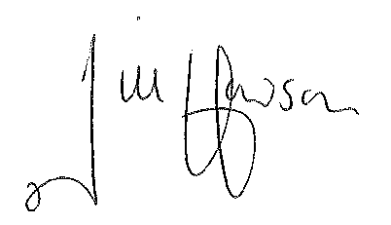**SIGNATURES:**

_______________________ _______________________ __________________________

**HEAD TEACHER PARENT CHILD**

2 September 2019

_______________________ _______________________ __________________________

**DATE DATE DATE**

***Appendix 3***

 **Acceptable Use Agreement for Early Years**

**2019/20**

#### This is how we stay safe when we use computers:

 I will ask a teacher or adult if I want to use the computers/iPads.

 I will only use activities that a teacher or adult has told me to use.

C:\Program Files (x86)\Microsoft Office\MEDIA\CAGCAT10\j0292982.wmf I will take care of the computer and iPads.

 I will ask for help from a teacher if I am not sure what to do.

 I know that if I don’t listen to the rules I might not be allowed to use a computer/iPad.

Signature (child) _______________________________________

Full Name (child) _______________________________________

Signature (adult) _______________________________________

Date _________________________________________________



**Acceptable Use Agreement for Key Stage 1**

**2019/20**

#### This is how we stay safe when we use computers:

 I will ask a teacher or suitable adult if I want to use the computers/iPads.

 I will only use activities that a teacher or suitable adult has told or allowed me to use.

C:\Program Files (x86)\Microsoft Office\MEDIA\CAGCAT10\j0292982.wmf I will take care of the computer and other equipment such as iPads.

 I will ask for help from a teacher or suitable adult if I am not sure what to do or if I think I have done something wrong.

 I will tell a teacher or suitable adult if I see something that upsets me on the screen.

 I know that if I don’t listen to the rules I might not be allowed to use a computer/iPad.

Signature (child) _______________________________________

Full Name (child) _______________________________________

Signature (adult) _______________________________________

Date _________________________________________________

**Acceptable Use Agreement for Key Stage 2**

**2019/20**



* I will use the school computers and technology sensibly
* I will ask permission from an adult before I look at the internet
* I will only log on using my own username and password which I will keep confidential
* I will only look at my own work and not delete anyone else’s files
* I will not bring in a USB from home without permission
* I will only email people I know
* I will always be polite and use appropriate language when emailing or sending messages on the computer
* I will not give out my personal information or arrange to meet anyone
* If I think anything on the internet upsets me or a stranger sends me a message, I will tell an adult
* I know Rosh Pinah will check my computer and be able to see what I am doing and what sites I have visited
* If I break these rules I know I may be stopped from using the internet and/or computers.

Signature (child) _______________________________________

Full Name (child) _______________________________________

Signature (adult) _______________________________________

Date _________________________________________________

***Appendix 4***

**Consequences - Levels**

|  |  |  |  |  |  |
| --- | --- | --- | --- | --- | --- |
|  | **LEVEL** | **EXAMPLES OF POOR BEHAVIOUR** | **STEPPED SANCTIONS** | **ACTION BY** | **INFORMATION PROCESS** |
| Levels 1 and 2 should be dealt with by classroom staff and middle leaders | 1 Low level disruption | Not following instructions  Talking out of turn  Not working  Talking back (defiance) | **Five steps in the classroom**:  I Verbal warning 1  II Verbal warning 2  III Reflection + 1 min detention | Teacher | Teacher records on class dojo  Visual record in class |
| 2 Disobedience  Obstructive  Behaviour | Continuation of Level 1  Friendship issues  Inappropriate language, including swearing, racist or homophobic comments  Inappropriate use of equipment including ICT in class or playground  Out of class without permission  Physically hurting another pupil | IV Move classrooms + 2 min detention  V 10 min detention | Teacher  Phase leader | Teacher records on class dojo  Step 4/5 incident sheet  Visual record in class  Call home |
| Level 3 and 4 should be dealt with by phase leaders supported by senior leaders | 3 Continued disruption  Destructive behaviour  Aggressive behaviour | Continued disruption of lesson  Vandalism  Graffiti and other property damage  Bullying  Aggressive and abusive language | VI SLT detention  VII and VIII Report card  This may also include withdrawal of privileges at the discretion of the Headteacher | Phase/  Senior Leader | Teacher records on class dojo/logged on SIMS  Serious Behaviour Incident form  Logged on SIMS by office  Call home +  Letter home |
| 4 Repetition of level 2&3 | Threatening and abusive behaviour  Aggressive disobedience  Assault  Causing significant damage  Continued disruption of lesson  Deliberate defiance/ disobedience | VIIII Internal/External exclusion  This may also include withdrawal of privileges at the discretion of the Headteacher | Teacher, support staff  Phase/  Senior Leader | School Behaviour Incident form  Logged on SIMS by office  SIMS  Call home  Letter  Parent’s meeting |