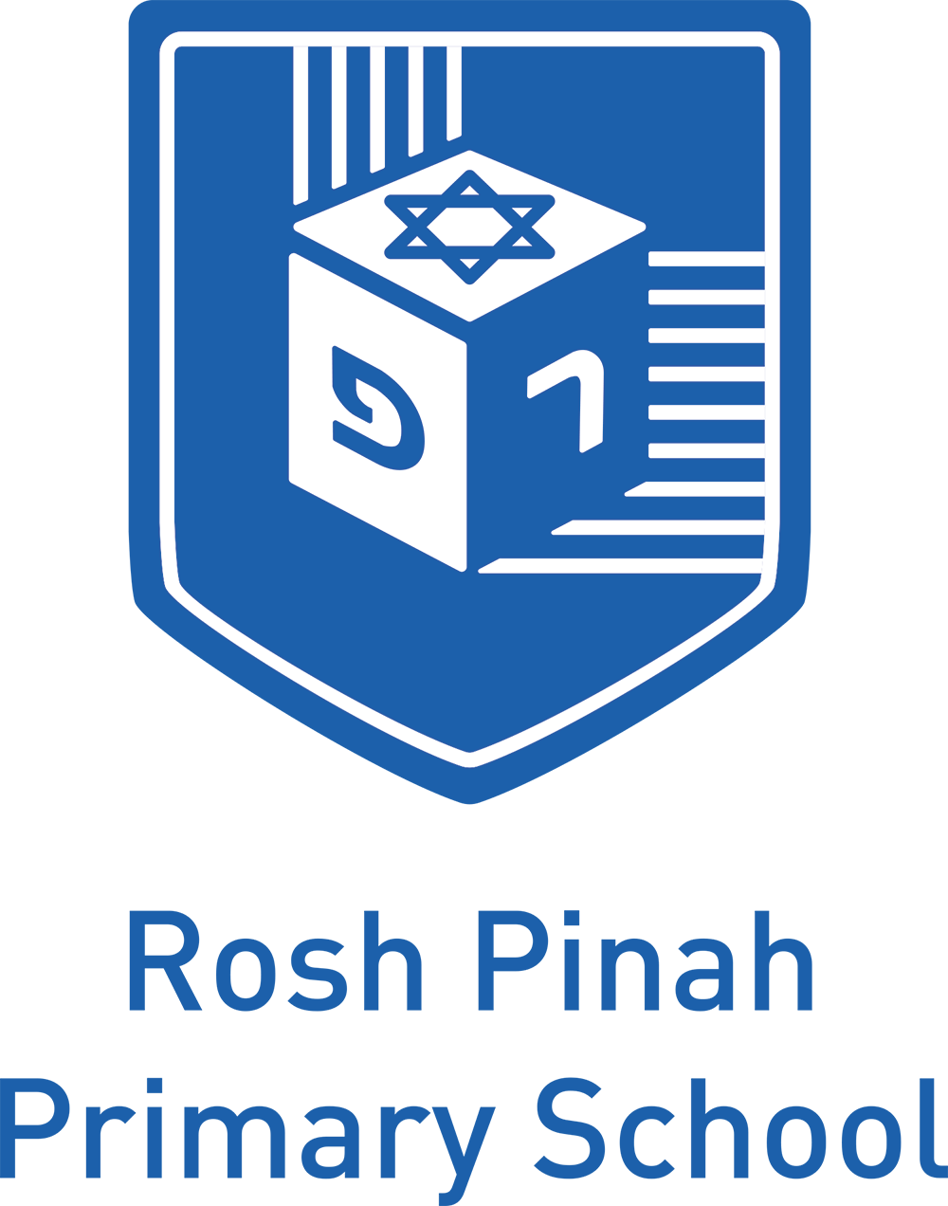

Foundation Stage Behaviour Management Policy

Ratification by Full Governing Body: October 2014
RATIONALE
We believe that children and adults flourish best in an ordered environment in which everyone knows what is expected of them and children are free to develop their play and learning without fear of being hurt or hindered by anyone else.

AIMS
We aim to teach children to behave in socially acceptable ways and to understand the needs and rights of others. The principles guiding management of behaviour exist within the programme for supporting Personal, Social and Emotional Development in the EYFS (Early Years Foundation Stage)

IMPLEMENTATION
- We discuss and agree rules governing the conduct of the staff and the behaviour of the children. These are explained to all newcomers both children and adults.
- We ensure that the rules are applied consistently,so that the children have the security of knowing what to expect and can build up useful habits of behaviour acknowledging the variety of cultural behavioural patterns.
- We provide a positive model for the children with regard to friendliness, care and courtesy.
- We praise and endorse desirable behaviour such as kindness and willingness to share.
- We take positive steps to avoid a situation in which children receive adult attention in return for undesirable behaviour.

ENCOURAGING POSITIVE BEHAVIOUR
We use positive, pro-active strategies to promote good behaviour and incorporate these strategies into our programme for Personal, Social and Emotional Development. These include:
- Organising the learning environment so that it has a positive impact on behaviour in terms of space, access and choice of activities.
- Promoting children’s confidence and self-esteem by enabling them to be successful in play experiences and activities.
- Circle time to reinforce good behaviour or any issues arising.
- Praising and promoting considerate behaviour by providing a range of rewards for the children, for example, stickers, Mitzvah (good deed) apples presented in assembly, and a mention in the newsletter.

WHEN CHILDREN BEHAVE IN UNACCEPTABLE WAYS:
- Physical punishmentwill neither be used nor threatened.
- Children who misbehave will be given one-to-one adult support in seeing what is wrong and working towards a better pattern.
- Where appropriate this might be achieved by putting the child’s name on amber or red on the class ‘traffic lights’ in Reception or by a period of “time out” at the “Thinking Stop”. Children will never be left isolated.
- In cases of serious misbehaviour, such as racial or other abuse, the unacceptability of the behaviour and attitudes will be made clear immediately, but by means of explanations rather than personal blame.
- In any case of misbehaviour, it will always be made clear to the child or children in question that it is the behaviour and not the child that is unwelcome.
- Staff will not shout, or raise their voices in a threatening way.
- Staff will themselves be aware of, and respect, a range of cultural expectations regarding interactions between people.
- Any behaviour problems will be handled in a developmentally appropriate fashion, respecting individual children’s understanding and maturity.
- Recurring problems will be tackled by the team of Early Years Staff, in partnership with the child’s parents, using objective observation records to establish an understanding of the cause.
- Staff will be aware that some kinds of behaviour may arise from a child’s special educational needs or disability this and may require the involvement of the SENCO with parent’s permission.

BEHAVIOUR MANAGEMENT PLAN
Our Early Years Class Rules and Behaviour Management Plan has been developed in conjunction with all staff with a recognition to create a healthy balance between recognition and consequences with both being clearly explained and specified.
The emphasis is on positive and intelligent discipline. The broad principle is based on our moral purpose which is to treat our pupils with respect and in the way you expect them to treat you. This moral impetus underpins the schools approach to discipline and will aid the generation of a civilised ethos and environment to work.

FOUNDATION STAGE CLASS RULES
- Do as you’re told when you’re told
- Listen carefully
- Take care of your classroom and resources
- Share and take turns
- Tidy together
The Foundation Stage Class Rules are also represented pictorially

REWARDS AND SANCTIONS
Pupils should learn to expect recognition for positive behaviour and fair and consistently applied consequence for inappropriate behaviour. We operate on a hierarchy of rewards and corrective interventions and consequences, working from the least to the most praiseworthy/ intrusive.
The hierarchy is made explicit to the children as is the link between the behaviour and the consequence.

REWARDS
- Verbal praise
- Stickers
- Feedback to parents • Star of the week
- Post card sent home

Mitzvah apples weekly for good deeds.
Star of the week with mascot and weekend diary sent home on Friday

SANCTIONS
- Verbal warning
- Thinking stop
- (Reception to use Traffic lights in addition)
- Conversation with Parents
- Behaviour plan

ROUGH AND TUMBLE PLAY AND FANTASY AGGRESSION
We recognise that young children often engage in play that has themes such as superhero and weapon play. We regard these kinds of play as pro-social and not as problematic or ‘aggressive’ and acceptable within limits, although it may be inconsiderate at times and may need addressing.

BULLYING
Bullying does not usually occur in children under five as they need to have reached a stage of cognitive development where he or she is able to plan to carry out a premeditated intent to cause distress to another.
If a child bullies another child or children:
- We show the children who have been bullied that we are able to listen to their concerns and act upon them.
- We explain to the child doing the bullying why her/his behaviour is not acceptable.
- We give reassurance to the child or children who have been bullied.
- We help the child who has done the bullying to recognise the impact of their actions.
- We make sure that children who bully receive positive feedback for considerate behaviour
- We share what has happened with the parents of the child who has been bullied, explaining that the child who did the bullying is being helped to adopt more acceptable ways of behaving.

ATTENDANCE
At Rosh Pinah PrimarySchool we believe that good school attendance gives children the opportunity of success and helps develop skills for life. We believe it is vital that all children attend school every day unless there is an unavoidable cause like illness. Every child should aim to end the year with attendance above 95%.

An Attendance Award will be given out every Monday to the class in Reception or KS1 that has achieved the highest attendance for the previous week. The Reception or KS1 Class will look after our attendance bear called ‘DovNochechon’ (Present Bear!) We also given termly attendance certificates for those with 100% attendance.

OTHER RELATED POLCIES
This policy also links to Rosh Pinah Policies on:

- How to Raise a Concern
- Teaching and Learning
- Code of Conduct for Staff, Volunteers and Governors
- Inclusion Policy
- Rosh Pinah Behaviour Management Policy (Main School)

This policy will be reviewed annually with opportunities for consultation with staff, pupils and parents.

Named Person
The named person for Behaviour Management is Sarah Mordecai.

