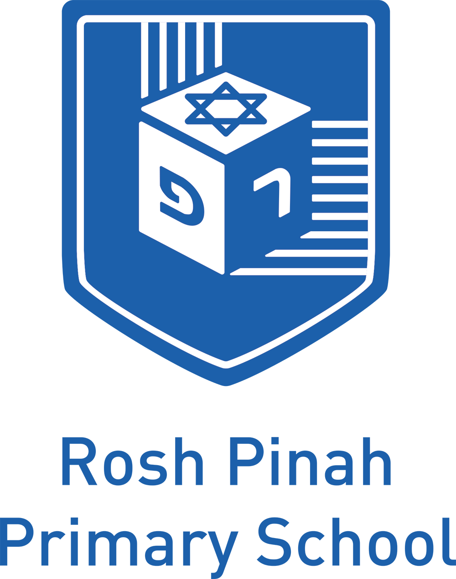

In-Year Admissions Policy 2024/25
Updated February 2023

Admissions Criteria – In Year 2023/24
The Rosh Pinah Jewish Primary School is a Scopus Jewish Day School. The religious character of the School is that of Modern Orthodox Judaism, as described in more detail in the statement of the School’s ethos which can be found on the school’s website. We ask all parents applying for a place here to respect this ethos and its importance to the school community. This does not affect the right of the parents who are not of the faith of the school to apply for and be considered for a place here.
The school is unable to offer places to children without an application to the London Borough of Barnet. The School’s own certificate of Religious Practice (CRP) must be completed and submitted to the school. Eligibility is determined by reference to information contained in the CRP. If a CRP is not provided an application cannot be considered.
Application Process: In order to make an application to the school you will need to complete and return to the London Borough of Barnet, a Barnet (CAF) and return to Rosh Pinah School, the School’s Certificate of Religious Practice (CRP) and the School’s Supplementary Information Form (SIF) with 2 Forms of proof of primary current address, current council tax bill and utility bill – (mobile phone bill or bank statements will not be accepted).
The School’s criteria give preference to those applicants with 4 points on the CRP ranked in order of date of confirmed application by Rosh Pinah Primary School. If in the event of over-subscription the following criteria give preference to children who have attained and verified four (4) points on the School’s Certificate of Religious Practice (CRP)
Your application is on a year by year basis and applications need to be renewed for each academic year.
In the event of over-subscription, places will be offered in accordance with the following criteria:-
Over-Subscription Criteria: The over-subscription criteria gives preference to children who have attained and verified four (4) points on the School’s Certificate of Religious Practice (CRP). In the event of over-subscription, places will be offered in accordance with the following criteria:
- Looked after or previously looked after children who ceased to be looked after because they were adopted (or became subject to a residence order or special guardianship order) who have 4 points on the CRP. The definition of a “looked after child” is by reference to footnote 16 to paragraph 1.7 of the Admissions Code.

- Children who have 4 points on the CRP with a sibling enrolled at the School at the time of application and the sibling is due to continue to attend the School after the child enters the School.

- Children of all staff who have 4 points on the CRP where the member of staff has been employed by the School for 2 or more years at the proposed date of entry.

- Children who have 4 points on the CRP who are siblings of former pupils of the School.

- Other children who have 4 points on the CRP.

- Looked after or previously looked after children who ceased to be looked after because they were adopted (or became subject to a residence order or special guardianship order) who do not have 4 points on the CRP. The definition of a “looked after child” is by reference to footnote 16 to paragraph 1.7 of the Admissions Code.

- Any other children who do not have 4 points on the CRP.

Tie-Breaker

In the event of there being more applicants than places available within criteria 1-7 above, priority will be given to children whose Primary Residence is closest to the School. Distance is measured in a straight line between the address point from the child’s home supplied by Ordnance Survey, to the School’s main gate using the Council’s computerised geographical information system. In cases where more than one applicant lives equidistant from the School, and places cannot be offered to all these children, the available place will be determined by random allocation supervised by a person independent of the School.

Please see guidance notes for Clarification.

Guidance Notes:

“Primary Residence” means the address which the child lives at during the School week. In cases of split residence, if the child regularly lives at more than one address Monday to Friday, the primary address provided should be the address where the child spends the majority of his/her time. If the child lives at two addresses equally, the address of the parent/carer that claims child benefit/child tax credit will be considered as the child’s primary residence (for the purposes of distance measurement). If the child lives at two addresses equally and the family is not in receipt of child tax credits the address used will be the address where the child is registered with a GP. It does not include more distant relations who live at the same address. Subject to this definition the School applies the rules and criteria of Barnet LBB, as set out in Barnet’s applicable guide to School admissions. Proof of residence is required before the offer of a place is confirmed.
“Siblings” includes half-siblings, step-siblings and adopted siblings, whether or not they live at the same address. It does not include more distant relations who live at the same address. Legal documentation will be required to be submitted at the time of application as evidence of half (birth certificate), step (marriage certificate) and adopted (adoption certificate) siblingship.
“School” means Rosh Pinah Primary School, i.e. for children from Reception to Year 6.

Distance Measurement: All distances to be measured hereunder will be measured by the shortest route using the London Borough of Barnet’s School’s Admissions team measurement tool. Distance is measured in a straight line between the address point for the child’s home supplied by the Ordnance Survey to the School’s main gate using the Council’s computerized geographical information system. Applicants from the same block of flats, or applicants who live the same distance from the school will be selected in random order.

Pupils with a Statement of Special Educational Needs: The admission of pupils with an Education, Health and Care Plan is dealt with by a completely separate procedure and outside of the normal admissions round. Details of this separate procedure are set out in the Special Education Needs Code of Practice. This procedure is run by the Local Authority and if a child with a Statement is placed in the School via the Local Authority before the normal admission offers are made, the number of places may be reduced.
Twins and children from Multiple Births: These children will be admitted when one of the siblings is the 60th child and, as a result, the School’s PAN will be increased.
Appeals: Parents have the right to appeal against the refusal to admit a child to the School. This should be done in writing to the Clerk to the Appeals Committee at the School and received within 20 School Days from the date of notification of an unsuccessful application. Further Details regarding the appeals process can be found on the School website.
In Year Fair Access: The Admissions Forum may require the School to admit a child exceptionally, either outside the normal admissions arrangements or in excess of the published admission limit, in order to protect the interests of vulnerable children and those with challenging behaviour. These pupils will be shared between School in ways that are fair, objective and transparent.
In-Year Admissions: Applications can be made at any time (please see our In-Year Admissions application form on the School website) and there is an appeals procedure if it has not been possible to offer a place at that time. This should be done in writing to the Clerk to the Governors within three weeks of the notification of the refusal of a place.
Change of Address: If the offer has been made on a geographical basis; it is conditional upon your still being resident at the application address at the beginning of the Autumn Term 2023 and may be withdrawn if you move further away from the School.
Applicants from Nursery: There is no guarantee or right to a place in the Reception year following attendance at the Rosh Pinah Nursery. Parents must apply via the local authority where the child lives.
Response by Parents: A parent who does not respond to the offer of a place may have the offer withdrawn if the deadline quoted in the email or letter is not met.
Late Applications: All applications for the Reception year received between 15th January 2023 and 31 August 2023 will be considered “late” and will be processed after those that have been received on time. The application procedure is otherwise the same, save that all forms should be returned without delay. Following the application procedure for Reception year places, and once initial offers have been made, the waiting list will be adjusted to include late applications.
FALSE INFORMATION
Places can be withdrawn after an offer has been made if it is found that the offer was made on the basis of misleading or fraudulent information.

